**RESEARCH**

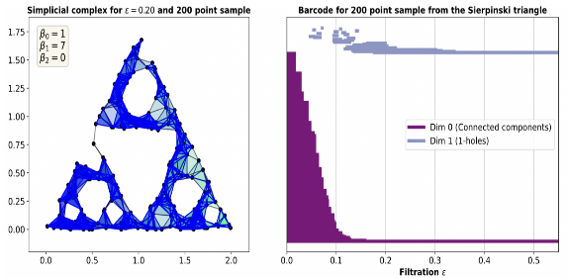*Fractal Dimensions of Complex Networks: Advocating for a Topological Approach,* accepted (under revisions) to Springer WinCompTop3 volume; preprint arxiv:2506.15236

* Motivate the use of persistent homology to estimate fractal dimensions of networks through experimentally comparing the Hausdorff dimensions and dimensions obtained from persistent barcodes on increasing subsample sizes of the Sierpinski triangle network (Python, R).

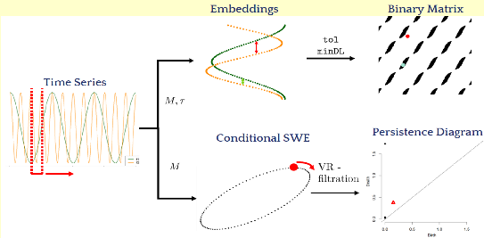*A Stable Measure for Conditional Periodicity of Time Series Using Persistent Homology,* submitted; preprint arxiv:2501.02817

* Use persistent homology to construct a scoring function that quantifies how similar a given pair of time series’ periodicities are (R).

*A Persistent-Homology Based Measure of Chaos in Dynamical Systems: Improving Stability* (in progress)

* Use persistent homology to construct a more-stable exponent that quantifies chaos in nonlinear dynamical systems when compared to traditional methods (R).

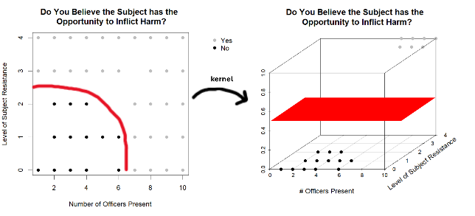*Perceptions of Force Severity, Operationalizing Reasonableness with a Repeated Measures Design,* in progress

* Use machine learning classification techniques to identify whether or not the order in which police-community interactions are observed and logically broken down impacts perceptions of severity, immediate threat, active resistance, and evasion in these encounters (Python)

Washington State Data Exchange for Public Safety (WADEPS) tutorials

* 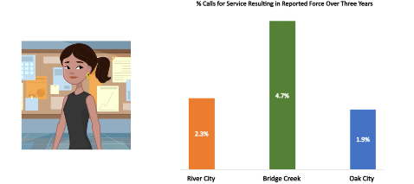Author scripts of [short video tutorials](https://wadeps.org/how-it-works/learn-about-stats/videos/) educating the public on finding reasonable agency comparisons and performing contextual analysis of agency patterns of behavior (R, Python, Adobe After Effects).

**TEACHING**

*Math 202: Calculus for Business & Economics lecture*, FA 2023, WSU Vancouver

*Math 103: Algebra Methods & Functions lecture,* Summer 2023, WSU Vancouver

*Math 108: Trigonometry lecture*, Summer 2022 & 2023, WSU Vancouver

*Math 140 Lab:* Calculus for Life Sciences, Fall 2021 & 2023, WSU Vancouver

**PRESENTATIONS**

[*What Can Donuts Tell Us About Body Cam Data*](https://www.youtube.com/watch?v=iu7vNOukW00&t=3550s)*?* 2nd Place WSU-wide 3MT finals, WSU Pullman, March 2023 (oral)

*A Stable Measure for Periodicity Similarity of Time Series Via Persistent Homology*, ATMCS 11, Bozeman Montana, July 2025 (poster)

*A Stable Measure for Periodicity Similarity of Time Series*, Cascade RAIN 9, Corvallis OR, April 2025 (oral)

*A Stable Measure for Conditional Periodicity of Time Series Using Persistent Homology,* Joint Mathematics Meetings, January 2025 (oral)

*Using Persistent Homology for Classification*, WSU Vancouver, January 2025 (seminar)

*Using Video Tutorials to Navigate Data Analysis in a Public Safety Open Data Exchange,* American Society of Criminology, November 2024 (oral)

*Perceptions of Force Severity, Operationalizing Reasonableness with a Repeated Measures Design,* Western Society of Criminology, February 2024 (oral)

**WORKSHOPS & SUMMER SCHOOLS**

*EWM-EMS Summer School: Stability in Topological Data Analysis,* Institut Mittag-Leffler, Djursholm Sweden, June 30 – July 4, 2025

* Learn about techniques for proving stability in persistent homology and work in small groups on an open problem improving stability of persistent homology classification algorithms.

*Women of Computational Topology Session 3* (WinCompTop3), Lausanne Switzerland, July 2023

* Work in a small research group led by Nina Otter for one week on an applied topology project using persistent homology to estimate the fractal dimensions of complex networks.

**EDUCATION**

PhD in Mathematics, Washington State University, May 2026

BS in Mathematics & Secondary Education, Linfield University, May 2021